Life Saver Blood Bank

Software Requirements Specification

Version-1.2

Date: June 11, 2020

Mohan Pratapa
Venkata Hareesh Bhuma
Raghunandan Kumar Naishadam
Sumanth Gorantla
Venkat Prudhvi Dommaraju

Submitted in partial fulfilment
Of the requirements of
CSIS 44-691 Graduate Directed Project 1

Date | Description | Author | Comments
6/10/2020 | Version 1.1 | Mohan Pratapa, Raghunandan Naishadam | Updated requirements and added ER Diagram
6/11/2020 | Version 1.2 | Raghunandan Naishadam,  Venkat Prudhvi Dommaraju | Updated document with prototypes

Document Approval

The following Software Requirements Specification has been accepted and approved by the following:
Signature | Printed Name | Title | Date

Table of Contents

Table of Contents Page Number

- Introduction
  - Purpose
  - Scope
  - Definitions, Acronyms, and Abbreviations
  - References
  - Overview
- General Description
  - Product Perspective
  - Product Functions
  - User Characteristics
  - General Constraints
  - Assumptions and Dependencies
- Specific Requirements
  - External Interface Requirements
    - User Interfaces
    - Hardware Interfaces
    - Software Interfaces
    - Communications Interface
  - Functional Requirements
  - Use Cases
  - Class/Objects
  - Non-Functional Requirements
3.5.1. Performance
3.5.2. Reliability
    - Availability
    - Security
    - Portability
  - Inverse Requirements
  - Design Constraints
  - Logical Database Requirements
  - Other Requirements
  - Prototypes (for complete project)
  - Use Case Diagrams
- Design
4.1. ER diagram
4.2. GUI
- Analysis Models
5.1. Data Flow Diagram
5.2. Sequence Diagram

Introduction

1.1 Purpose:
The purpose of our application is to let the users who are in need of emergency for blood can login to the Life Saver Blood Bank application and can request the donors for blood. Once the request is placed by the users based on the availability of the blood group.

1.2 Scope:
New user opens the application and register using his/her details. If the user is already registered, he/she needs to login using his/her credentials. When the emergency occurs, for all users i.e. existing and new users the application displays the available donors where a request can be made online. The request is fixed once the user clicks the submit button. Later he/she can view the requests which were placed by him/her. User can go through his/her profile in settings where he/she can edit his/her credentials including his/her mobile number. Once the user request is submitted then blood donor can accept based on his/her availability.
1.4 References:
- https://www.ncbb.org/

2. General Description

2.1 Product functions:

Initially to use the app user should signup and create an account using email id or phone number. Then user has to login to the application using the credentials. Based on the emergency, all the donors will be displayed. By clicking on the required blood group, user can see all the details of that particular donor. User can select a particular blood group and request the blood. Then the request will be sent to the donor where they can either accept or reject the request. Once the request is accepted, user’s request is confirmed.

3. Specific Requirements

3. Specific Requirements
Life Saver Blood Bank is an application where the users can get responses from the donors online. Here, Donors are the clients and application is the link to make the requests for users. So, the main purpose of the application is to make the users find the blood in case of emergency with ease.
Application is build according to progressive enhancement principles. Responsive design for varying screen size, Version compatibility for devices, more touch flexibility and less keyboard usage in the application are the features of application. The other main feature is application and data security.
3.1 External Interface Requirements
3.1.2 Hardware Interfaces (computers and servers)
- This application must be able to install in any android device with version greater than or equal to 5.0
- Android devices must have Internet services.
- The user should give access to Internet once the app gets installed in his/her android device.

3.1.3 Software Interfaces (programming Lang)
- Android Studio has to be installed on all the Laptops.
- Java has to be installed on all the Laptops.
- Java will be used as a programming language to develop the application.

3.2 Functional Requirements:
- This app will help the users to find blood in case of emergency.
- This app will have Users and Donors.
- A Registration activity page will be used by both the users and donors for registration into the application.
- To use the application, one must login with appropriate details.
- Password Retrieval: If user forgot password then he can reset it with phone number or email.
- The Donors Page will have the list of all the donors and their details.
- The Users should be able to search all the donors based on the blood group.
- User should be able to select the donor and place a request to the donors.
- The Users should be able to contact the donors once the request has been approved by the donors.
- Notifications should be received by both the users and donors.
- We should have a database to store all the data such as user information and all their request details.
- A logout page should be available for the users to logout of the application.

3.5.1 Performance:
- This app should be user-friendly.
- This app should have less response time.
- This app should not crash at any situation.

4. Design

4.1 ER Diagram:

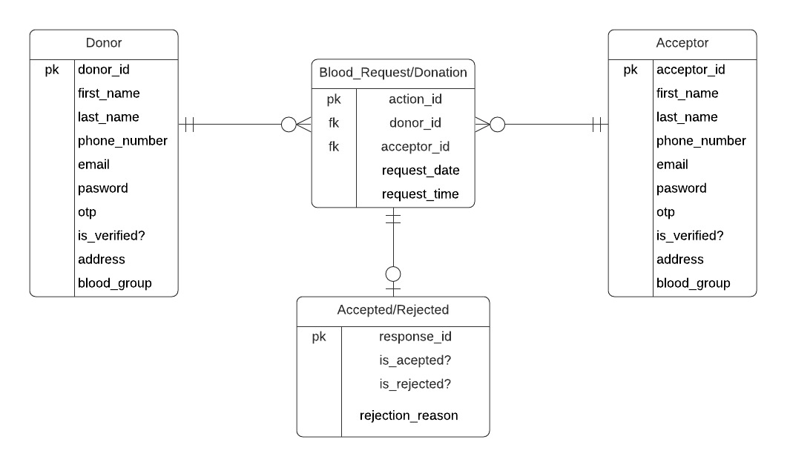
Description:

If the user creates his account make an action such as requesting and accepting blood donation requests, he should either be donor or recipient. One acceptor can make as many requests as required and so as the donor. So we established mandatory one to optional many relationships between Blood_request/donation, donor, and acceptor entities. If the donor accepts/rejects the requests then there should be a donation request, so the relationship is mandatory one to optional between Blood_Request/Donation to Accepted/rejected entities.

4.2 GUI:
1. Launch Screen:
This is the launch screen of our application. It will be displayed whenever the application is launched.
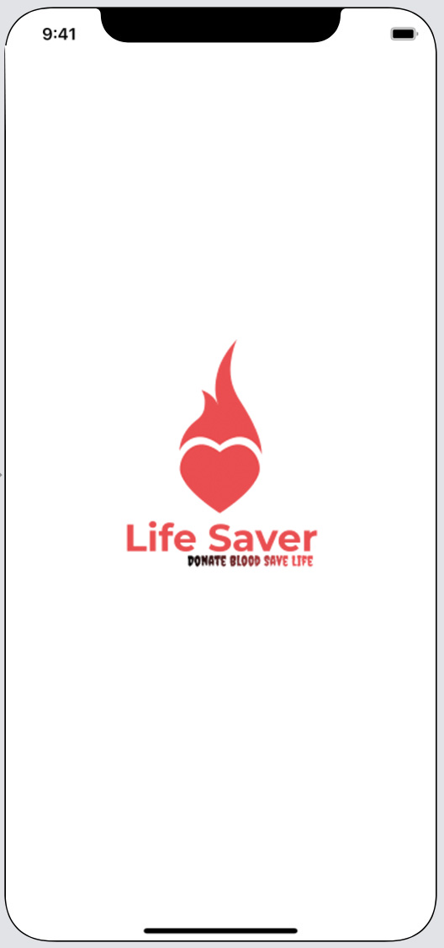
- Sign in Screen:
This is the Sign in screen where user has to log in with their respective credentials.

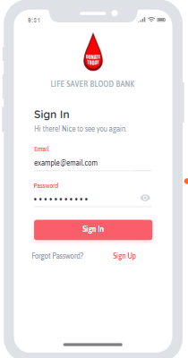

- Sign Up Screen:
This screen is used for registration activity. Users and Donors will register here.

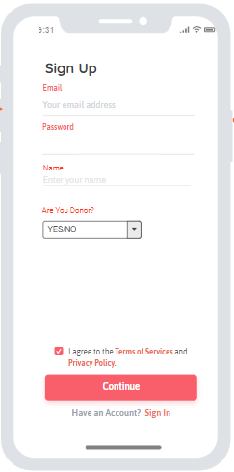
- Donor Home Screen:
This is the screen where the complete details of the donors will be available and can view the requests done by the users.

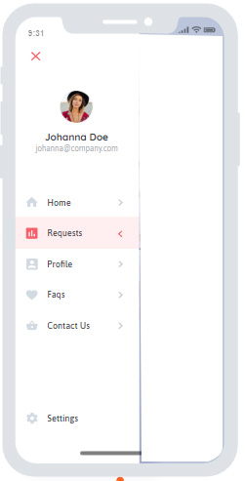

- Requests Screen:
This is the screen where all the requests done by the users will be available.

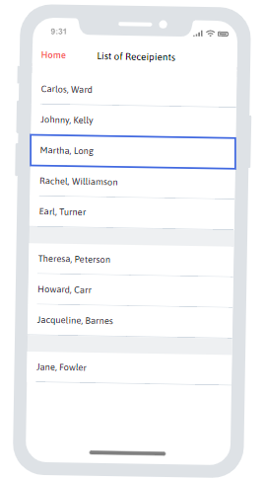

- Acceptor Home Screen:
In this screen the details of the acceptors can be able to view the list of donors for a particular blood group.
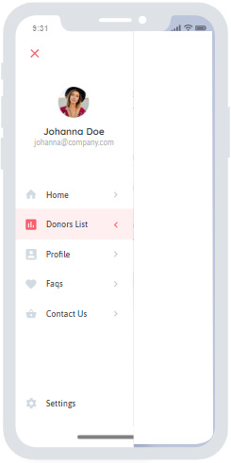
- Donor list Screen:
The complete list of donors who are willing to donate the blood can be seen here.

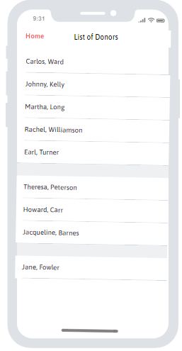
- Profile Screen:
The users can edit their profile settings in the Profile screen.

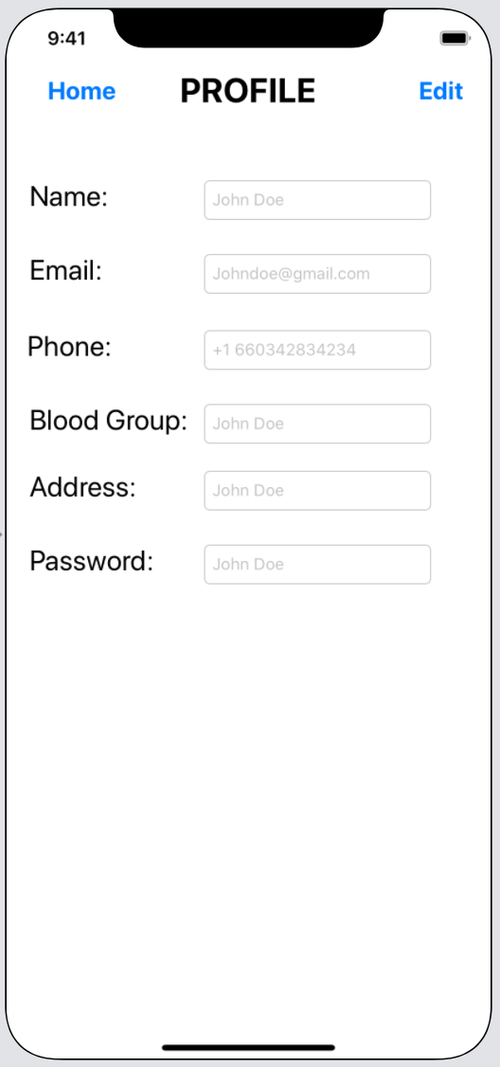

- Contact Us Screen:
If the users face any issues with the app, they can file their issues in the Contact Us screen.
